How to get a Pre- Approval Letter:

- Input the purchase price, taxes and hoa dues from the subject property
- Verify with your buyer their desired down payment amount and loan program (if applicable).
- If the status displays “qualified” you will be able to touch “Get Preapproval Letter” and receive a custom letter via email in seconds.
How Conditions are
displayed:
1. Select your buyer and then touch the conditions tab.

2. This screen will show you what conditions are still outstanding, which have been rejected, approved or are waiting for approval.

The myMobileLO - Quick Start Guide
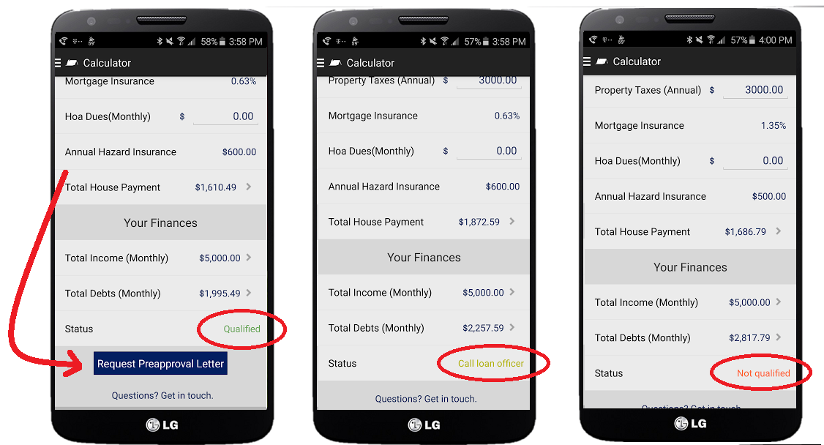
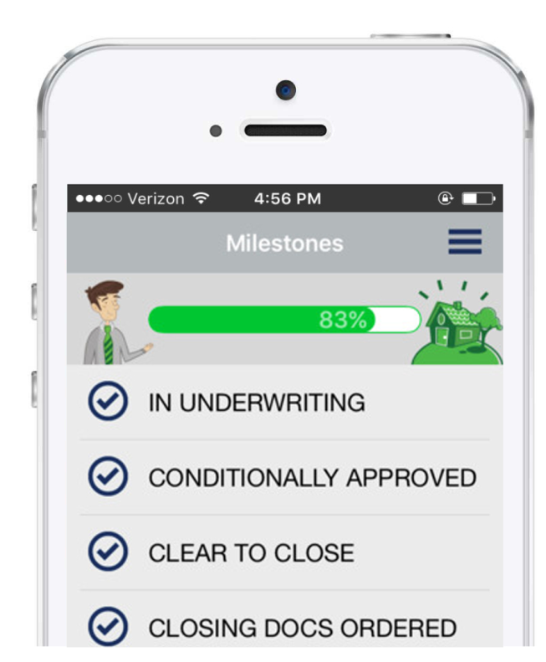
Quick Tip: All of the tabs you need are accessed using the “hamburger” button located at the top of the screen.

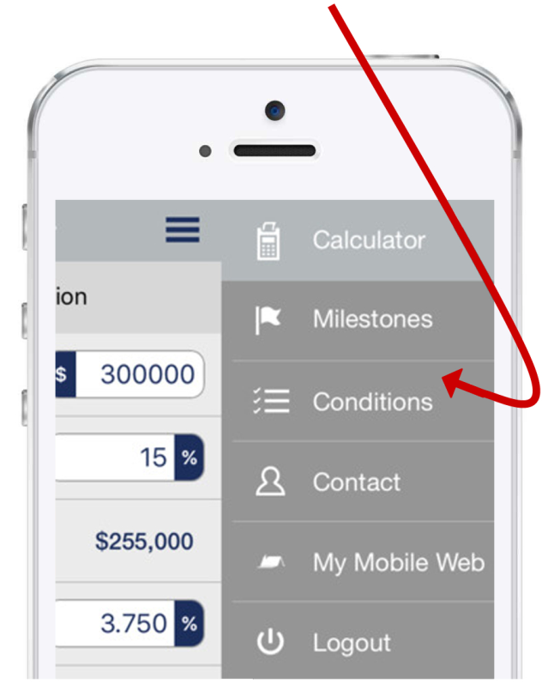
How will my App communicate with you?

1. You will receive push
notifications and emails
whenever a new milestone
is reach in the loan process
for your buyer.
2. You have access to a
real time “thermometer”
at any time by touching
the milestones tab in your
selected buyer’s profile

Note: When you first log in you are always greeted with your "buyers list". Simply select a buyer and you can check their progress 24/7. Never be left out in the dark again!

